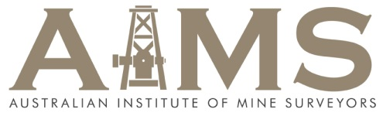
Award Application Form 2016

Name of Award | AIMS Best Technical Presentation Award

Nominee
name
Address
Telephone | work | home |  |  | mobile
email | work |  | home
Preferred contact method  (Circle one) | At home/work  By phone/email  any
Signed applicant/nominee |  |  |  | Date

Nominator  name | If applying for self tick here ( ) &skip remainder of section
Address
Telephone | work |  | home |  | mobile
email | work |  |  | home
Preferred contact method  (Circle one) | At home/work  By phone/email  any
Signed by nominator |  |  |  |  | Date

Office only
Date received

Consent  Award Criteria | Do you agree to be contacted by AIMS members regarding your submission? Yes / No  Do you agree to present your submission at the AIMS National Conference? Yes / No  Applicants will be judged against the following criteria:  - Ease of understanding the written paper and or presentation  - Technical completeness  - Originality  - Personal involvement in writing the paper / seminar talk
Name of Paper
Abstract or topic outline
Number of pages?
Where published or presented?
Date published or presented?

Attachments | Attach copy of presentation or paper in electronic format
Any other attachments?
(optional)

Please send completed forms to: secretary@minesurveyors.com.au

